
Big Data Intelligence on Logistics
An experimental study

¹Akhil P Sivan, ²Jisha Johns, ³Jayasurya Venugopal
Dept. of Computer Science & Engineering
Christ University Faculty of Engineering, Bangalore, India
Email : ¹akhil.sivan@cse.christuniversity.in, ²jisha.johns@cse.christuniversity.in, ³Jayasurya.venugopalan@christuniversity.in

Abstract—The logistics industry is competing in a changing and continuously challenging world. As our economy is moving into this new information age, logistics industries are facing a lot of challenges as well as opportunities. The advancement of E-commerce and evolution of new data sources like sensors, GPS, smartphones etc exploded the business with large amount of real-time and near real-time data. However, to deal with such a large amount of data and to gain business insights, logistics firms requires faster and comprehensive data collection and analytics technologies. This paved the way for Big data analytics on the logistic information. In this paper, we discuss the opportunities and analysis capability of technologies like Big Data and Hadoop for supporting the current ways of doing business and future innovation. Thus this paper presents a modern approach to information management and analytics in order to achieve operational efficiency for logistic firms.
Index Terms—Big Data analytics, Hadoop Data Platform, Zookeeper, Apache Hive, MapReduce.

INTRODUCTION
Big Data has quickly transformed from the confined realm of a technology to become a business priority, that can provide solutions to the long-standing business challenges. It is powerful to transform the process, organization and even the entire industry itself. It helps to unlocks new insights which are inherent with the data. In fact, new technologies and data management frameworks are required to capture, store and analyze both structured and unstructured data from new data sources[4]. Big Data is characterized by the 3 V’s: Volume, Velocity and Variety, which the legacy systems based on related data bases cannot handle without sacrificing any ACID properties. Volume denotes the huge amount of data that Big Data denotes, whose starting point is from Terra Bytes(TB) and is varying depends on the scenario. Velocity denotes the rate at data gets generated from different sources like streaming of data from sensors and video cameras. Variety denotes the different data and file types that are available to process. So Big Data can efficiently deal with the sensor data from logistic vehicles in a way to gain business values by performance monitoring and improvement and advanced analytic capabilities.
Big Data can broadly classified into two categories: Human generated digital foot prints (like data through social networking sites etc ) and machine data ( like log files saved by routers, switches, firewalls etc). A large part of these are unstructured data that Big Data can efficiently handle. Open source Hadoop has the biggest recognition in Big Data world which includes the components for solving issues of distributed data management and analysis[6].
The various sensors, GPS system etc attached to logistic vehicles capture data and send it on timely manner to Data management servers. The clustered servers can extract various information with the help of distributed and fault tolerant computing environment provided by Hadoop[3]. A logistic firm can have thousands of vehicles sending Geographical information and sensor data. Streamlining the maintenance operations, decrease field cost are the targets of Big Data intelligence on Logistics.

BIG DATA & ANALYTICS
The logistic industry is undergoing a fundamental shift from the product-related services to information related services. The customers are empowered with always connected and intelligent information world, which changes the demands and communication requirements with technologies available[2]. So companies has to adapt and adopt to the changing customer demands and at the same time recognize the availability of new data sources and management frameworks. It can generate new sources of revenue for the company.
- Volume: In logistic industry, due to widespread digitization (like taking user signatures through smartphones and electronic billing information etc ), the data volume is growing in a great pace.
- Velocity: The amount of data getting accumulated at the servers is at higher rate taking the case of all vehicles of the company.
- Variety: Big data deals with both structured and unstructured data that involves different kinds of data have to be incorporated for analysis and getting insights.

SYSTEM FRAMEWORK
  - System architecture and components
The system architecture is created on the open source Apache Hadoop framework. Hadoop solutions are offered by companies such as Cloudera and Hortonworks. They offer open source implementations with commercial add-ons mainly focused on cluster management. Here we are using the Hortonworks Data Platform for the distributed data storage and processing.
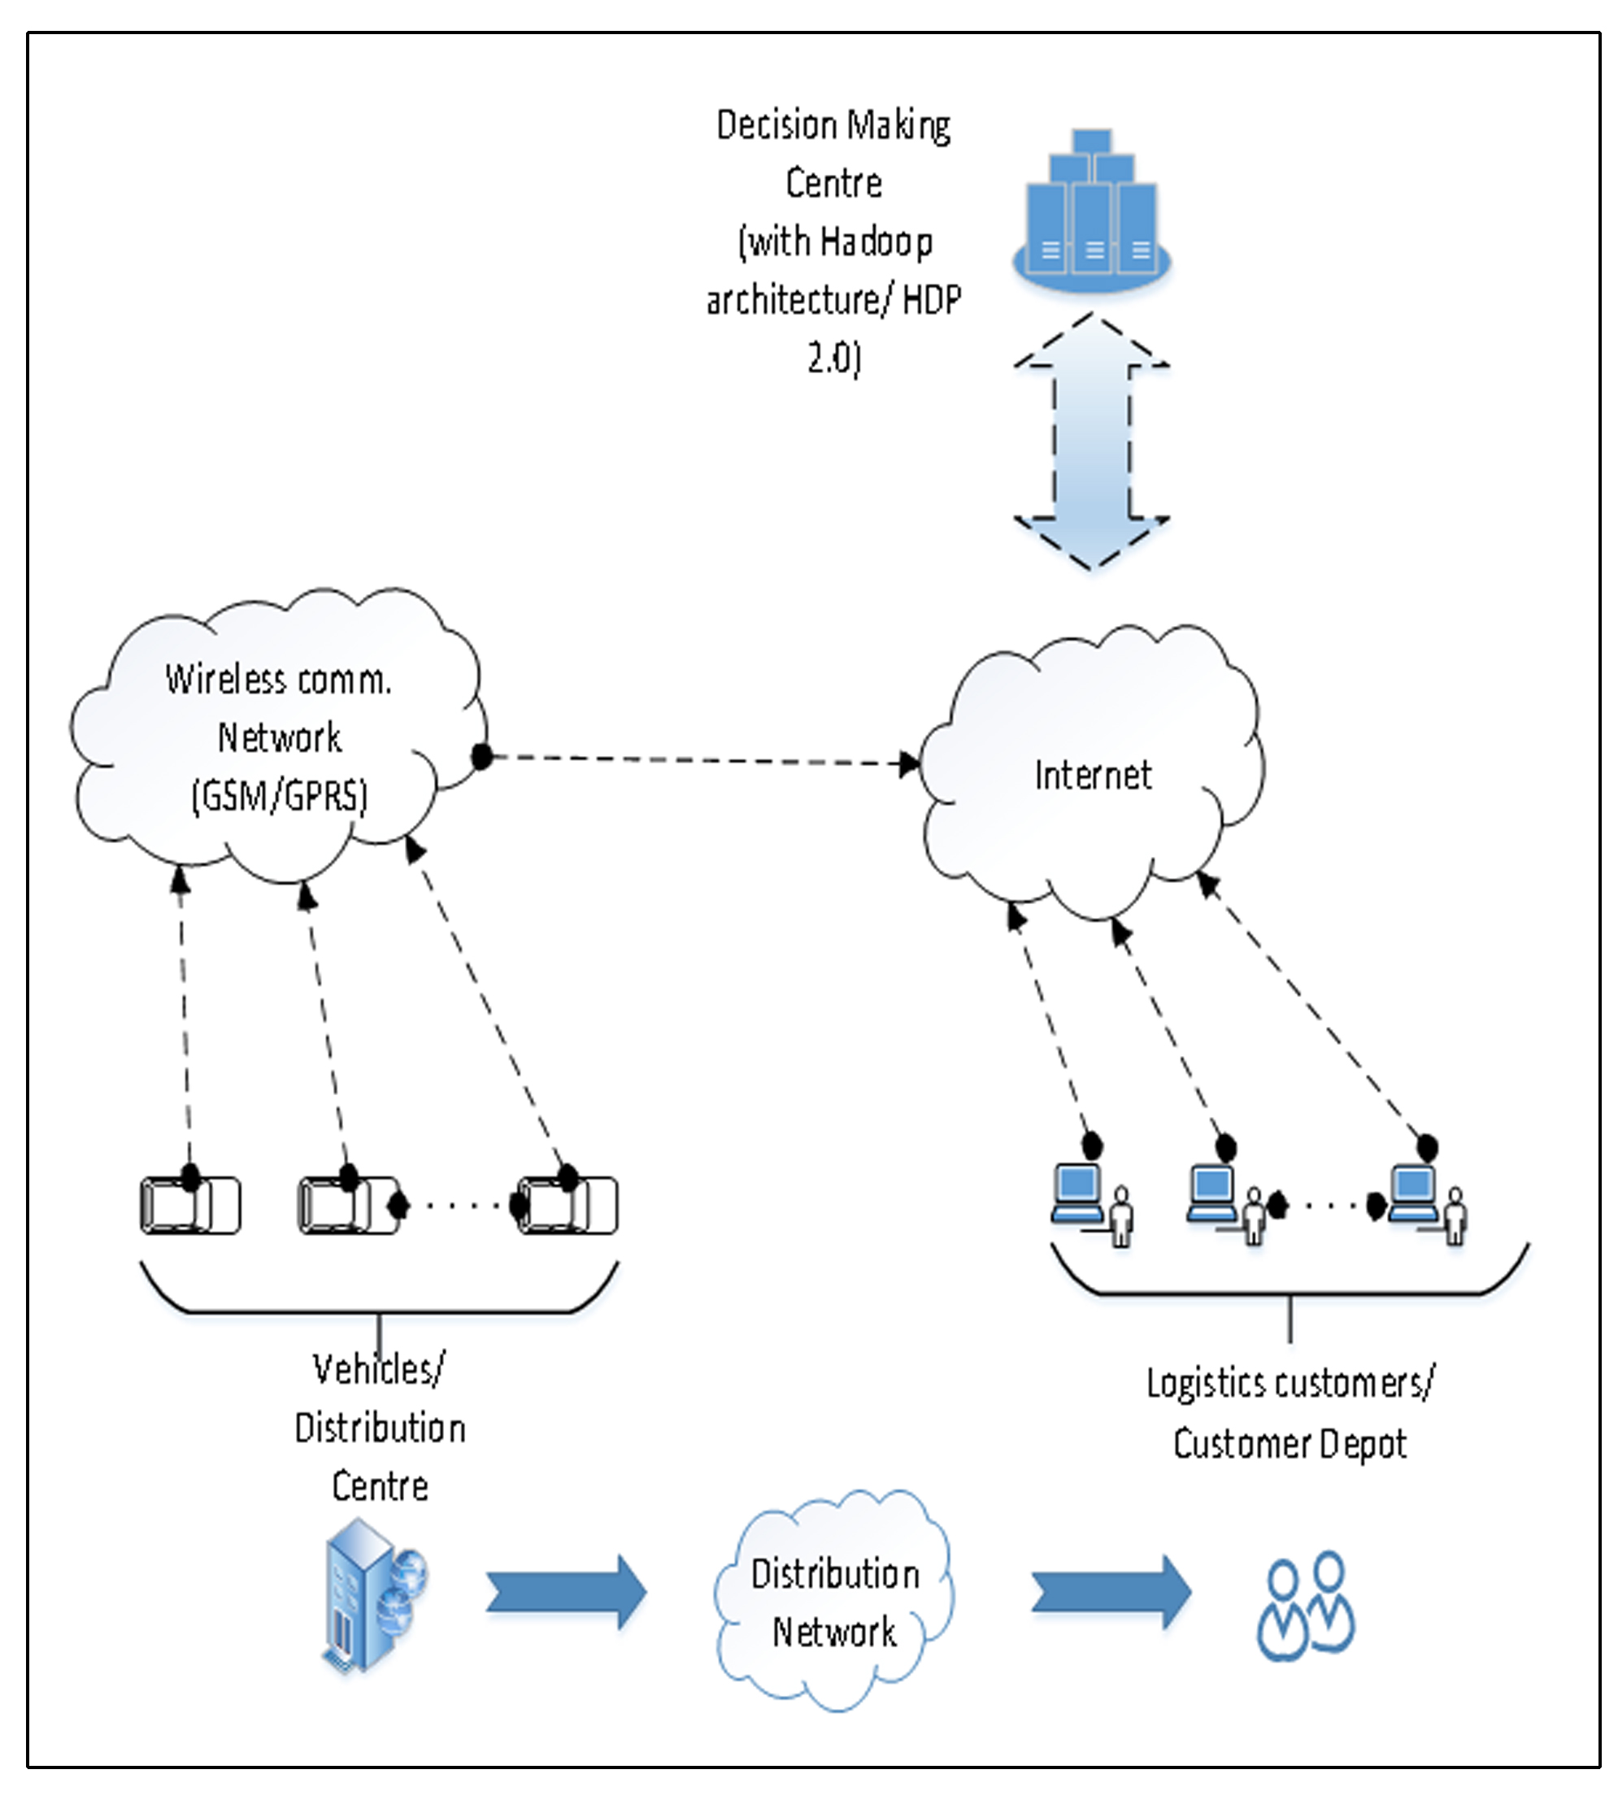
Fig. 1. System Dataflow
The figure above shows the data flow in the proposed system. The data from vehicles will passing over wireless communication (GPRS) to the clustered servers at the data processing center. The major device attached to the vehicles will be a GPS device with a SIM facility, it will send different packets at time intervals with information about fuel, speed, hard acceleration etc[7]. On the out of coverage areas these packets will be queued by the device and send when comes in coverage. Special fields are there in packets indicating normal packets or queued packets. This unstructured data can be combined with structured data about vehicle details and driver information in the clustered server to gain insights to answer the different metrics designed for analysis. The analysis is done with the help of two basic functionalities provided by the Hadoop framework:
- MapReduce: A programming model for executing the tasks in parallel, which consists of two steps Map and Reduce[5]. In Map step, a problem is broken down into many small ones and then sent to servers for processing. In Reduce step, the results of the Map step are combined to create the final results of original problem.
- HDFS: A distributed file system that not only stores the data but also ensures fault tolerance through replication.
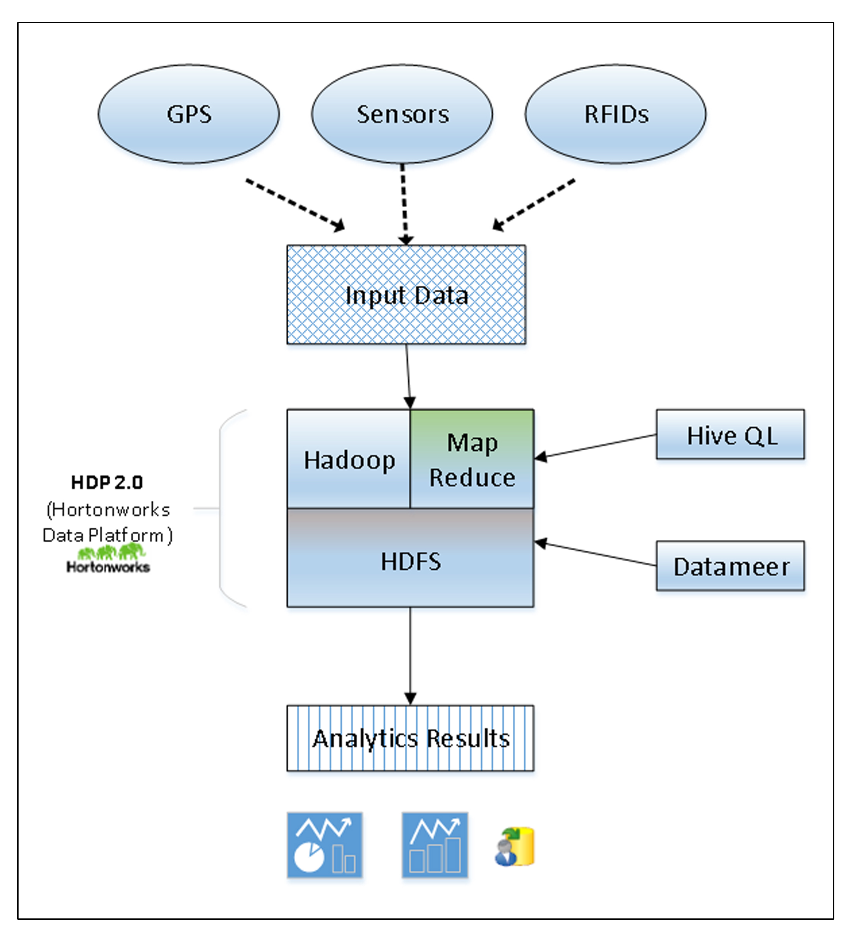
Fig. 2. System architecture diagram
The results of analysis can visualized with the help of data visualization tools like Datameer, through which the metrics used to perform analysis can be answered. The analysis may be performed on a weekly or monthly basis, which will be dealing with Terabytes of data. The insights which otherwise difficult to get can help the companies in optimizing the operational performance and reducing field operation cost.

OPERATION MECHANISMS
A sound decision making with the support of information from available geospatial and sensor data requires answering complex queries. And the amount of available data is being rapidly growing with the increasing dissemination of smart phones, digital sensors, social media etc. So analytics using Big Data and hadoop framework is of greater importance[8]. This paper demonstrates some of the opportunities.
Some of the metrics that can be applied on logistic information is given below:
- Which trucks are idling and wasting fuels
- Drivers with highest risk factor
- Trucks with worst gas mileage and where they are idling
- Negative driving patterns under control of drivers
- Pollution estimation of different vehicles
- Monitor the driving behaviors to improve productivity.
Like this several metrics can be formulated to become the basis of our analytics.

Tools and strategies
The customized hadoop ecosystem by Hortonworks includes several tools for managing, controlling and processing the data stored in HDFS[6]. Other than MapReduce and HDFS, the major tools in the Apache hadoop ecosystem which are useful for our analytics are:
- Hive: It is a higher level abstraction of hadoop functionalities and a data warehouse system in which the user can specify instructions using the SQL-92 queries and will get converted to MapReduce tasks.
- Pig: Pig is another high-level abstraction of Hadoop which is similar to the functionality of Hive. But it uses a programming language called Pig Latin, and it is more oriented to data flows.
- HBase: HBase provides a secure, reliable and integrated tool for fault-tolerant columnar storage and also provides quick access to large quantities of sparse data.
- Zookeeper: It provides operational services for the hadoop cluster including the synchronization and configuration. Distributed applications use Zookeeper inorder to store and mediate updates to important configuration information.
- Sqoop: This is a tool designed for the efficient transfer of bulk data between Apache Hadoop and the relational databases.

EXPERIMENTAL UNDERSTANDINGS
Through this work, we could study the feasibility of integrating Big Data analytics and hadoop framework for building up the intelligence in logistics industry. With the open source tools readily available, any Enterprise can adopt the secure and stable hadoop distribution by hortonworks. The insights based on the metrics can be found in more efficient way than legacy systems. We have taken the case of sensor devices attached to 100 vehicles, with each one sending different packets for fuel, speed, errors, latitude, longitude information etc. The packets are sending at 2-3 seconds difference, using GPRS/GSM. These sensor-data are getting stored at the servers on a rapid pace, extracting the information for real-time tracking purposes is already existing but using these stored data in large amounts to analyze driving patterns, fuel wastage of each vehicle owned by the company, and improving the driver efficiency so as to reduce the operation cost for the company is not existing, which is an effective application of Big Data analytics. The scheduled monthly analysis on the data with the help of hadoop distributions like Hortonworks Data Platform(HDP) can gain these benefits for the company. These benefits require more time and efforts with the traditional systems.
The packets are having different fields with separate identifiers. Here we are considering the fuel, speed and tracking packets for analysis to answer those metrics under consideration. So the data is loaded, refined and visualized with the help of HDP and Tableau, which is a visualization tool. The results can be generated in the form of graphs and charts to get better understanding on the analysis of large amount of data, that makes it easy to identify the trends and patterns. The Big Data analytics can earn more insights from data comparing to the traditional systems in the field of logistics and transportation industry that yields more business values.
Traditionally, the results of analysis were kept in spreadsheets or like tabular reports. But that makes it very challenging to find the trends, patterns and correlations exists in large set structured or unstructured data. Also the traditional spreadsheets and similar tools are no longer adequate for processing and analyzing multiple sources of data which the enterprises want to deal with. This is where the data visualization comes into the picture. Visualization using tools like Tableau helps to communicate complex ideas or patterns with more clarity and precision.

CONCLUSION
The legacy systems cannot provide the visibility, insights, control and mobility required to succeed in today’s transportation and logistics industry. The logistic firms has to focus on enhancing good quality services by satisfying customer needs and at the same time adapting and adopting the required technological advances like Big Data analytics, which can have a lot of positive impacts for the company and also the economy. So Big Data analytics is a fast growing area that spreads a wide variety of fields and in this paper we explored the opportunities in logistics industry.

ACKNOWLEDGMENT
This study is done as a part of Master’s Degree dissertation work in Christ University, Bangalore, India. I would like to thank my guide for the support.

REFERENCES
[1] Meijun Cai, Zhangxi Lin and Hao Su, “Dynamic Vehicle Routing Services with Anticipatory Optimization – A Decentralized Scheme Based on MapReduce”- Proceedings of the 15th International Conference on Electronic Commerce ICEC 2013
[2] Hongchun Hu and Yaohua Wu, “Research on Real Time Computer Simulation System of Urban Logistics Distribution Vehicle Routing Optimization Based on GIS”. Proceedings of the 16th International Conference on Artificial Reality and Telexistence--Workshops (ICAT'06).
[3] Ryota Ayaki, Hideki Shimada, Kenya Sato, “A Proposal of Sensor Data Collection System Using Mobile Relay Nodes*”, Wireless Sensor Network, 2012, 4, 1-7.
[4] Simon Ellis, “Big Data and Analytics Focus in the Travel and Transportation Industry”, September 2012.
[5] Rethink the supply chain, information management, analytics, and mobility in the freights and logistics environment”, by HP.
[6] Tom White, “Hadoop: The Definitive Guide Third Edition”.
[7] Sachchidanand Singh, Nirmala Singh “Big Data Analytics”, 2012 International Conference on Communication, Information & Computing Technology (ICCICT), Oct. 19-20, Mumbai, India.
[8] “Improving Decision Making in the World of Big Data” http://www.forbes.com/sites/christopherfrank/2012/03/25/improving-decision-making-in-the-world-of-big-data/.



